Detailed Data Description
This dataset includes annual mosaics of Antarctic ice velocity derived from Landsat 8 images between December, 2013 and April, 2019, which was updated in 2020 in order to produce multi-year annual ice velocity mosaics and improve the quality of products including non-local means (NLM) filter, and absolute calibration using rock outcrops data. The resulting Version 2 of the mosaics offer reduced local errors, improved spatial resolution as described in the README file.
Data Description
Parameters
The main parameter in these datasets is ice velocity, with associated error maps (in m/yr) and count images. The ice velocity over the fast ice is also include in the products. The Antarctic mosaic is equally divided into 16 subregions and each subregion are provided separately. The variables included in the data file are described in Table1. All variables are on a two-dimensional grid of 2800 by 2800 cells for each 500 m resolution subregion.
File information
Format
These datasets include 448 data files. The data file is stored in a 16-bit integer GeoTIFF file format under a polar stereographic projection with a true latitude at 71 degree.
File Contents
For ice velocity products
The 105×105-m gridded ice velocities for all of Antarctica are stored in a 16-bit integer GeoTIFF file format under a polar stereographic projection with a true latitude at 71 degree. The gridded ice velocity has been equally divided into 4 subsets in the X and Y directions in consideration of file size and computer processing speed (see Fig. S1). Note that file sizes have been kept at 1 Gigabyte for user friendliness and easy downloading. Each file contains three bands that show velocity vector components in both the X-direction and Y-direction and a gridded error map of the ice velocity. The structure of the ice velocity filenames is Velocity_l8_*begin date*_*end date*_*subset*_*XY* _*component*_v2.tif, where Velocity represents ice velocity data and l8 indicates the L8 satellite from which images are used to produce the ice velocity map. *begin date* is start date of the images that contributed to mosaic in format of ‘yyyyddd’, which ‘yyyy’ is four-digit start year and ‘ddd’ is three-digit day of start year, and *end date* is end date of images used in same format with start date. *subset* shows whether the ice velocity file has been cropped due to considerations of file size and computer processing speed, and *XY* indicates the relative coordinates among all files, where X is the column number starting with one and Y is the row number starting with one. *component* shows the components of velocity vectors by use of ‘vx’ and ‘vy’, which represents the easting and northing components. Furthermore, the annual mosaics of ice velocity are also provided. The naming convention is the same as the description mentioned above.
For count maps
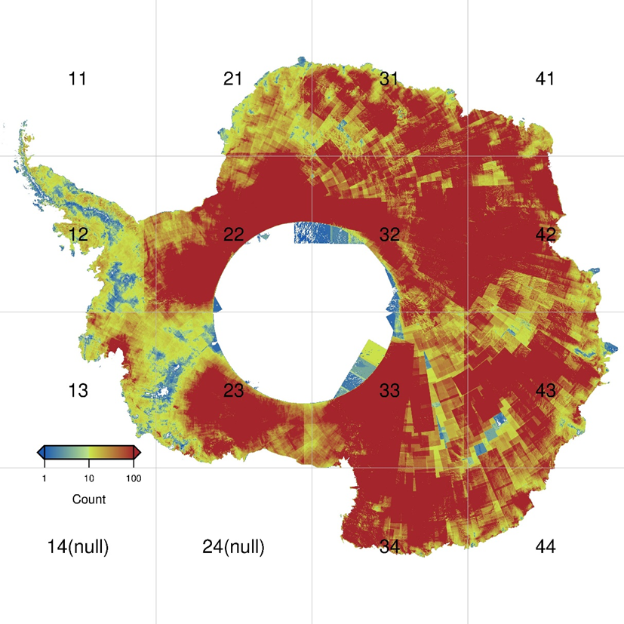
The count maps of number of ice velocity measurements for valid displacement maps stacked for ice velocity mosaics, and are stored in 16-bit integer GeoTIFF files (Fig. S2). These files also have the same file structure and projection as the gridded ice velocity maps. The naming convention of the count maps is Countimage_l8_*begin date*_*end date*_*subset*_*XY*.tif, which has the same naming convention as the ice velocity maps, except for “Countimage”, which indicates the content of the product.
Figure S1. Numbers of ice velocity mosaics, including displacement maps between 2013 and 2019, over Antarctica, illustrated ice flow data coverage. The counts are color-coded on a logarithmic scale. The gridlines and labels define the 16 subregions in mosaicking process.

Spatial Information
Coverage
Spatial coverage includes the whole continent of Antarctica, namely the entire polar region southwards of 60° S.
Resolution
Here, we provided spatial resolution of the grid (500 m by 500 m). The 105 m by 105 m grid products are separately provided by personal communication.
Temporal Information
Coverage
The data were collected between December 2013 and April 2019.
Resolution
Yearly. The averaged maps 2013-2019 and 2013-2016 are also provided which can be distinguished by file names.
Version 2 Updates
Version 1 of the Antarctic ice velocity mosaics are affected by the number of images used, post-processing, absolution calibration. Version 2 benefits from the following improvements and updates:
- The order of the Landsat 8 images was used for the more annual ice velocity mosaics (2013-2019).
- NLM filter was first introduced to preserve the fine details and suppress the errors, which benefits the spatial details compared to Version 1.
- The rock outcrop data derived from Landsat8 were used to absolution calibration, which improves the georegistration.
Contacts and Acknowledgments
Investigators:
Dr. Qiang Shen^{1,2}
1Innovation Academy for Precision Measurement Science and Technology, CAS
State Key Laboratory of Geodesy and Earth’s Dynamics
Wuhan 430077,
China
2 University of Chinese Academy of Sciences,
Beijing 100049,
China
Prof. Hansheng Wang^{1,2}
1Innovation Academy for Precision Measurement Science and Technology, CAS
State Key Laboratory of Geodesy and Earth’s Dynamics
Wuhan 430077,
China
2 University of Chinese Academy of Sciences,
Beijing 100049,
China
Prof. C. K. Shum
The Ohio State University,
Division of Geodetic Science, School of Earth Sciences,
Columbus, Ohio 43210, USA
Prof. Liming Jiang^{1,2}
1Innovation Academy for Precision Measurement Science and Technology, CAS
State Key Laboratory of Geodesy and Earth’s Dynamics
Wuhan 430077,
China
2 University of Chinese Academy of Sciences,
Beijing 100049,
China
References
- Qiang Shen, Hansheng Wang, C. K. Shum, et al. Recent high-resolution Antarctic ice velocity maps reveal increased mass loss in Wilkes Land, East Antarctica. Sci Rep 8, 4477 (2018). https://doi.org/10.1038/s41598-018-22765-0
- Qiang Shen, Hansheng Wang, C. K. Shum, Liming Jiang, Hou Tse Hsu, Jinglong Dong, Song Mao, and Fan Gao, Earth Syst. Sci. Data Discuss., https://doi.org/10.5194/essd-2018-149, 2018

